**RNN:**

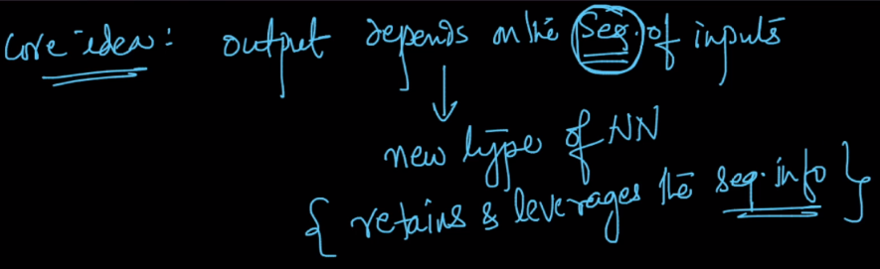

**RNN is used wherever we need the sequence or order of information to get observation from that, or if output is depends on the sequence of input then RNN is used**

EX: Amazon fine food review, there we were using bow, tfidf, w2v to convert text into numerical features, but all those techniques are not preserving order. And if see eg given in below image we need to retain order to find out the context of the sentence so we can find out proper output.

Other use cases:

1. Time Series analysis: In such problem there is information related to the time, that means for the sequence of time we have information associated with it and hence RNN is used.
2. Machine Translation: As we seen in above Amozon eg, we need sequence of words to be retained to find the context of the word, similarly in machine translation or language translation like English to hindi we need to find context so that we can get most accurate translation.
3. Speech Recognition: we need the words spoken before to know the context of the word spoken currently.
4. Image Captioning.

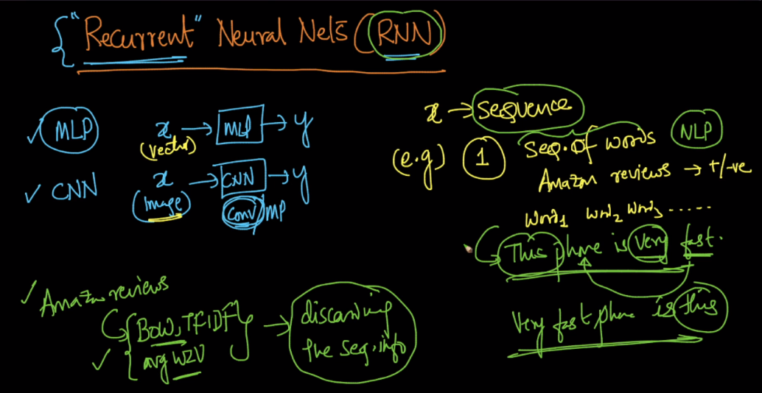

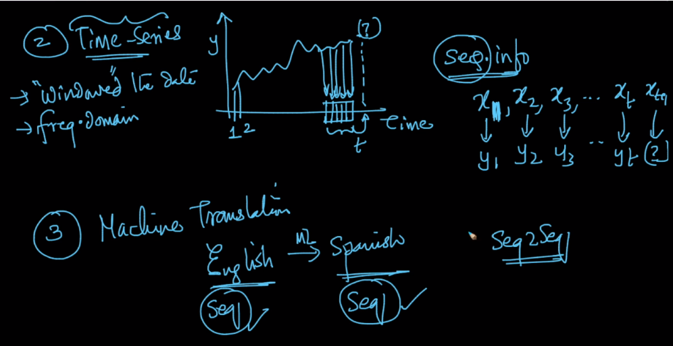 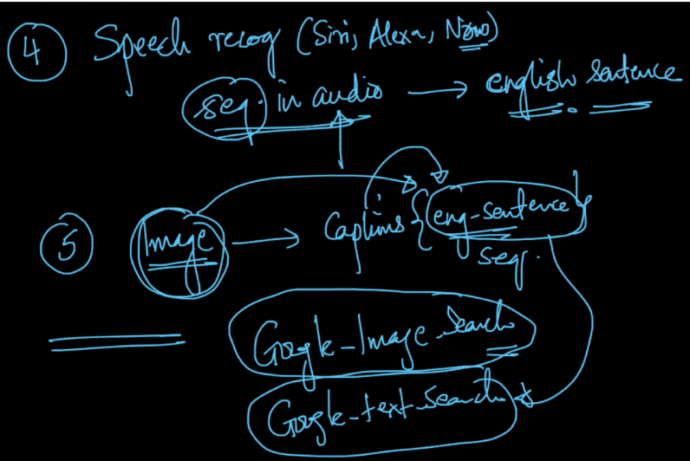

**So one argument can be that we can train a MLP where the input is the one hot encoding of each word in a sentence and hence we can retain sequence.**

Let’s say we have vocabulary of size 10k, therefore each word encoding will be of size 10k. Now suppose a sentence contains only 5 words so input to network will be 50k, 10k for each word, which is a **very big size, this is the first problem.**

**Second**: now another sentence comes of size let’s say 7 word, so now we’ll have 70k size input, but this problem can be overcome by fixing the input size by size of max length sentence in training set.

But problem with this approach is let’s say max-len sentence length is 20 words, now in test or real time for model the input come which has 25 words, so this **is another problem.**

And because of such problems RNN is used.

